# SALT SSL login configuration

The file login.aspx should be moved to a folder called “Restricted” and the SSL settings for that folder should be set to “Require SSL”:

Select the “Restricted” folder, select “SSL Settings”

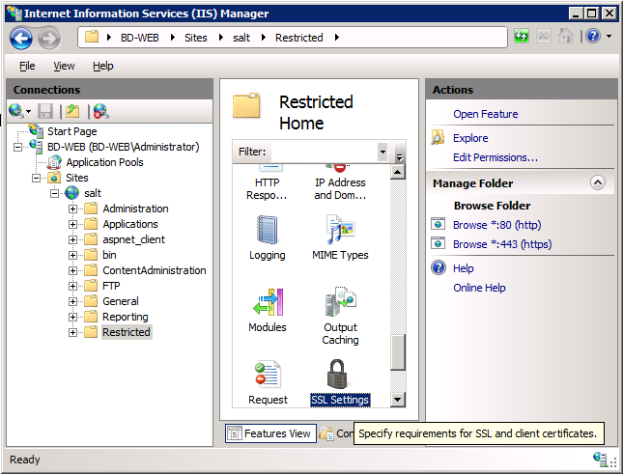

Select “Require SSL”

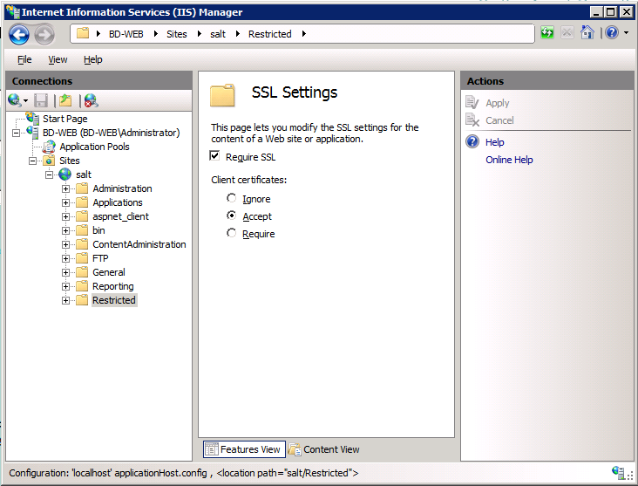

Select the SALTTM Website and select “Authentication”

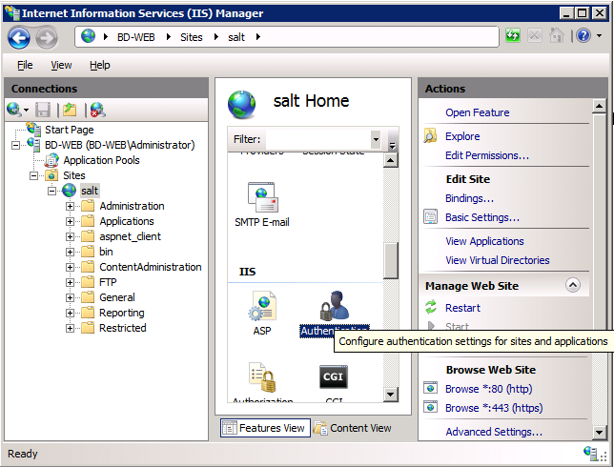

Select “Forms Authentication” and choose “Edit”

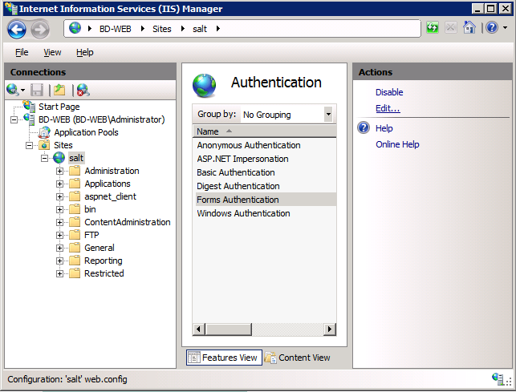

Change the “Login URL:” to /Restricted/Login.aspx

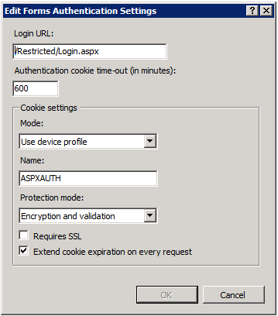

DO NOT tick “Requires SSL”

Copy any other files that are required for authentication and menus into the “Restricted” folder. (Bin and General\UserControls folders)

Run SALT from the new URL

i.e.

<https://localhost/Restricted/Login.aspx>